
COMSATS UNIVERSITY ISLAMABAD, Wah Campus

Lab Report
---------------------------------------------------------------------
MUHAMMAD UMER RAFIQ (FA23-BAI-013)

SUBJECT: Introduction to Computer Vision

Sir: Dr. Jamal Hussain Shah

DATE: 08-Oct-2026
LAB 05: HOG-Based Industrial Defect Detection and Classification

1. Introduction
In a steel factory the surface of every sheet has to be checked. Most of the time a person does this by looking at it, and that is slow. A tired person can also miss a small scratch or a patch. In this lab I made a small computer vision system that looks at a steel surface image and decides if it is defective or not. The system uses HOG (Histogram of Oriented Gradients) features and a machine learning classifier. The pipeline is: image, then grayscale and resize, then HOG features, then the classifier, then a decision to accept or reject the product. I ran everything in Google Colab on a T4 GPU. I wrote the HOG part in PyTorch so that it runs on the GPU and finishes quickly.

2. Industrial Application
The application is automatic surface inspection of hot-rolled steel strips. A camera sits above the production line and takes a picture of the strip. If a defect is found the product is rejected or sent for a second check. If a defective sheet reaches the customer, the company loses money and trust, so it is better to stop it early. An automatic system gives the same decision every time and can work all day without getting tired.
HOG is a good fit here because most steel defects change the edges and the direction of the texture. A scratch makes a long straight edge, pitted surface makes many small dark spots, and inclusions make short dark lines. HOG also needs much less computing power than a deep network, so it can run on a small machine near the line.

3. Dataset Description
I used the NEU steel surface defect dataset (NEU-DET) from Kaggle. It has 1800 grayscale images of size 200x200, with 300 images in each of six defect classes: crazing, inclusion, patches, pitted surface, rolled-in scale and scratches. Every image also has an XML file with the bounding box of the defect. My loader did not find separate train and valid folders, so the code made its own stratified 80/20 split by image: 1440 training images and 360 test images (240 and 60 per class).
The dataset has no normal (good) images, so I had to make the binary task from the boxes. A defective sample is a 64x64 crop around the center of each defect box. A normal sample is a 64x64 crop from the same steel image in a place that does not touch any box. This gave 5663 training patches (3382 defective, 2281 normal) and 1334 test patches (807 defective, 527 normal). Because the split was done by image, crops from one image never go to both train and test. To choose parameters I kept 20% of the training images as a validation set (4548 train and 1115 validation patches), and the test set was only used at the end.

4. Image Preprocessing
The images are already single channel, and the code would convert color images to grayscale if needed. Each crop was resized to the same size, 128x128, with bicubic interpolation. Defective and normal crops go through exactly the same steps, so the size of the image cannot give a hint about the class. Pixel values are scaled to the range 0 to 1 inside the HOG function. I did not add a smoothing filter because it would remove the edges HOG needs. For the 6-class task the full 200x200 images were simply resized to 128x128.

5. HOG Feature Extraction
First the gradients in x and y are found with a [-1, 0, 1] filter, then the gradient magnitude and the angle (0 to 180 degrees). Each cell makes a histogram of angles, where every pixel votes with its magnitude and the vote is shared between the two nearest bins. Then 2x2 cells are grouped into a block, blocks move one cell at a time, and each block is normalized with L2-Hys (clip at 0.2). With 8x8 cells and 9 orientations on a 128x128 image there are 15x15 blocks of 36 values, which is 8100 features per image. I wrote this in PyTorch to use the GPU. I compared it with scikit-image HOG on a test image: the length was the same (8100) and the correlation was 0.88. It is not exactly equal because my version uses soft binning.
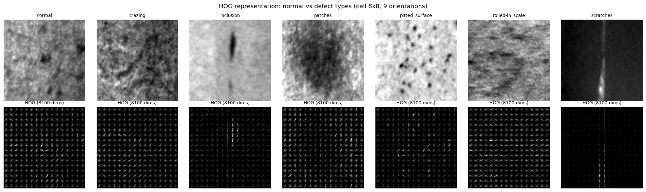
Figure 1. Normal patch and one defective patch of each class, with their HOG images (cell 8x8, 9 orientations).
In Figure 1 the scratch and the inclusion give a clear line of strong gradients. Pitted surface gives scattered small gradients. Crazing, patches and the normal patch look much more alike, with gradients in many directions, which already tells me these will be harder to separate.

6. Classification Methodology
The main classifier is an SVM with an RBF kernel (class weights balanced, gamma set to 1 / (number of features x variance)). I chose C = 10 on the validation set (validation F1 was 0.551 for C = 0.1, 0.781 for C = 1 and 0.815 for C = 10, 100 and 1000). To make training fast, the kernel matrix is calculated on the GPU and then solved with libsvm. As additional classifiers I trained a linear SVM, a Random Forest (300 trees), XGBoost on GPU (300 trees) and kNN (k = 5, cosine distance). Defective is the positive class, and I report accuracy, precision, recall and F1-score with a confusion matrix and classification report.

7. Experimental Setup
All runs used a Colab T4 GPU, Python, PyTorch, scikit-learn and XGBoost, with seed 42. The HOG experiment tried cell sizes 4x4, 8x8, 16x16 and orientations 6, 9, 12 (nine combinations) with the SVM, and the best one was picked on the validation set. After that all classifiers were trained on the full training patches and tested once on the test patches. For the robustness test I changed only the test patches and did not retrain: brightness (x0.5, x0.75, x1.5), Gaussian noise (sigma 10, 25, 50 on the 0-255 scale), rotation (5, 15, 30 degrees) and blur (sigma 1, 2, 3). I also tried training again with perturbed copies added to the training data.

8. Results
HOG parameters. Table 1 shows the nine combinations on the validation set. The best was cell 8x8 with 9 orientations (accuracy 77.04%, F1 0.8148). The 16x16 cell with 9 orientations was close (F1 0.8051) with only 1764 features. The 4x4 cell gave far more features (up to 46,128) but was not better, so it only made things slower. Nine orientations was the best choice for all three cell sizes.
Cell | Orient. | Features | Accuracy | Precision | Recall | F1
4x4 | 6 | 23064 | 0.7274 | 0.7525 | 0.8048 | 0.7778
4x4 | 9 | 34596 | 0.7318 | 0.7479 | 0.8260 | 0.7850
4x4 | 12 | 46128 | 0.7094 | 0.7311 | 0.8064 | 0.7669
8x8 | 6 | 5400 | 0.7327 | 0.7582 | 0.8064 | 0.7815
8x8 | 9 | 8100 | 0.7704 | 0.7809 | 0.8517 | 0.8148
8x8 | 12 | 10800 | 0.7274 | 0.7554 | 0.7988 | 0.7765
16x16 | 6 | 1176 | 0.7399 | 0.7765 | 0.7882 | 0.7823
16x16 | 9 | 1764 | 0.7650 | 0.7921 | 0.8185 | 0.8051
16x16 | 12 | 2352 | 0.7516 | 0.7799 | 0.8094 | 0.7944
Table 1. HOG cell size and orientations (HOG + SVM, validation set). The best row is shaded.
Classifier comparison. Table 2 has the test results with the chosen HOG settings. HOG + SVM (RBF) was the best overall, with 77.74% accuracy and F1 0.8195. Random Forest had the highest recall (0.88) but it missed many good surfaces (recall for normal only 0.57) and it took 251 seconds to train against 3.6 seconds for the SVM. XGBoost was close to the SVM, the linear SVM was clearly lower, and kNN was bad (recall 0.22), probably because distances in 8100 dimensions are not useful.
Model | Accuracy | Precision | Recall | F1 | Train time (s)
HOG + SVM (RBF) | 0.7774 | 0.8043 | 0.8352 | 0.8195 | 3.6
HOG + SVM (linear) | 0.7106 | 0.7795 | 0.7274 | 0.7526 | 8.6
HOG + Random Forest | 0.7579 | 0.7585 | 0.8798 | 0.8147 | 251.0
HOG + XGBoost (GPU) | 0.7639 | 0.7971 | 0.8178 | 0.8073 | 32.1
HOG + kNN (k=5) | 0.5157 | 0.9005 | 0.2243 | 0.3591 | 0.03
Table 2. Binary classification on the test set (1334 patches).
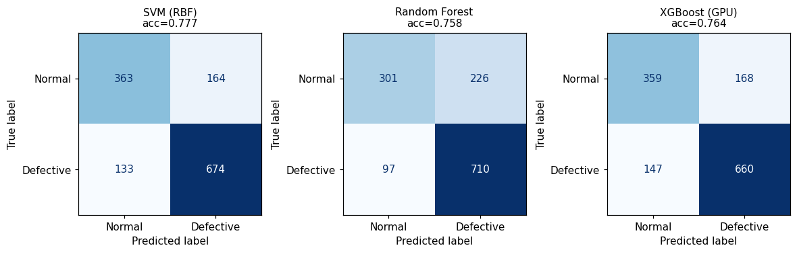
Figure 2. Confusion matrices on the test set: SVM (RBF), Random Forest and XGBoost.
For the SVM the confusion matrix is: 363 normal patches correct, 164 normal patches wrongly called defective, 133 defective patches missed and 674 defective patches correct. So the model finds defects better (recall 0.835) than it recognizes good surface (recall 0.689).
Multi-class (advanced task). On the full images with six classes, HOG + SVM reached 83.89% accuracy and macro F1 of 0.8367. Random Forest got 76.94% and XGBoost 80.28%. Rolled-in scale was perfect (F1 1.00), while pitted surface (F1 0.71) and patches (F1 0.73) were the weakest.

9. Robustness Analysis
Table 3 shows the change in accuracy and F1 for the SVM and the Random Forest. Both models act in a similar way.
Condition | Level | SVM Acc | SVM F1 | SVM dAcc | SVM dF1 | RF Acc | RF F1 | RF dF1
Clean | - | 0.7774 | 0.8195 | 0 | 0 | 0.7579 | 0.8147 | 0
Brightness | x0.5 | 0.7774 | 0.8195 | 0 | 0 | 0.7579 | 0.8147 | 0
Brightness | x0.75 | 0.7774 | 0.8195 | 0 | 0 | 0.7579 | 0.8147 | 0
Brightness | x1.5 | 0.7624 | 0.8169 | -0.0150 | -0.0026 | 0.7451 | 0.8146 | -0.0001
Noise | sigma 10 | 0.4205 | 0.0874 | -0.3568 | -0.7321 | 0.4340 | 0.1272 | -0.6875
Noise | sigma 25 | 0.3951 | 0.0000 | -0.3823 | -0.8195 | 0.3951 | 0.0000 | -0.8147
Noise | sigma 50 | 0.3951 | 0.0000 | -0.3823 | -0.8195 | 0.3951 | 0.0000 | -0.8147
Rotation | 5 deg | 0.6537 | 0.7678 | -0.1237 | -0.0516 | 0.6649 | 0.7795 | -0.0352
Rotation | 15 deg | 0.6477 | 0.7673 | -0.1297 | -0.0521 | 0.6529 | 0.7729 | -0.0418
Rotation | 30 deg | 0.6424 | 0.7640 | -0.1349 | -0.0555 | 0.6432 | 0.7700 | -0.0446
Blur | sigma 1 | 0.6057 | 0.7542 | -0.1717 | -0.0652 | 0.6049 | 0.7539 | -0.0608
Blur | sigma 2 | 0.6049 | 0.7539 | -0.1724 | -0.0656 | 0.6049 | 0.7539 | -0.0608
Blur | sigma 3 | 0.6049 | 0.7539 | -0.1724 | -0.0656 | 0.6049 | 0.7539 | -0.0608
Table 3. Test accuracy and F1 under different imaging conditions (dAcc, dF1 = change from clean).
- Brightness: making the image darker changed nothing, because HOG normalizes every block, so scaling the pixel values does not matter. Making it brighter (x1.5) cost only 1.5 points of accuracy, since some pixels reach 255 and get clipped.
- Noise: this is the biggest problem. Already at sigma 10 the accuracy falls from 77.7% to 42.1% and F1 to 0.09. At sigma 25 and 50 the accuracy is 39.5%, which is exactly the share of normal patches, so the model calls everything normal. Noise adds random gradients everywhere and the HOG vector no longer looks like the training data.
- Rotation: even 5 degrees lowers the accuracy by 12 points (F1 by 0.05), and 30 degrees is only a little worse. HOG is not rotation invariant.
- Blur: accuracy drops by about 17 points. From sigma 2 it is 60.5%, the share of defective patches, so the model calls everything defective (F1 stays around 0.75 only because of this).
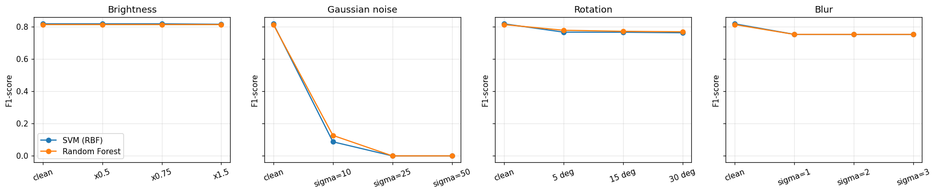
Figure 3. F1-score of the SVM and Random Forest under each imaging condition.
I also trained the SVM again with perturbed copies added (16,983 training samples). It helped with noise: at sigma 10 the F1 went from 0.087 to 0.634 and at sigma 50 from 0 to 0.578. Blur at sigma 1 improved in accuracy (60.6% to 66.8%). But the clean accuracy fell from 77.7% to 72.0% (F1 0.770), and rotation did not really improve (F1 about 0.72 to 0.74). So augmentation is a trade-off, not a full fix.

10. Industrial Deployment Discussion
The final decision module scans a full 200x200 image with 64x64 windows (stride 32, so 36 windows). The product is rejected if at least two windows have a defect probability of 0.5 or more, and the program prints the prediction, the confidence and the action (ACCEPT PRODUCT or REJECT PRODUCT). On the test images all 360 defective strips were rejected (100%), and one image took 50.4 ms. In the simulated video stream the full pipeline ran at 19.8 frames per second, and I also made a script (realtime_inspector.py) that shows PASS or DEFECTIVE on a webcam or video file.
But the numbers also show why this is not ready for a real line. On single patches the false reject rate for normal surface was 33.2% and 15.5% of defective patches were accepted. Rejecting one good product in three is too expensive. In a real factory I would collect real good-product images, tune the probability threshold and the number of windows on them, fix the lighting and camera position (because rotation, noise and blur hurt so much), add a denoising step, and send low-confidence products (in my demo many were between 56% and 70%) to a human for a second check.

11. Limitations
- The dataset has no real normal images. My normal class is made of defect-free crops of defective strips, so it is not the same as a truly good product.
- The binary accuracy is only about 78%, and I used one dataset with 200x200 grayscale images taken in a lab setting. A different camera, light or steel type may give worse results.
- I used one random split and one run, with no cross-validation, so small differences (for example between the 8x8 and 16x16 cells) may not be real.
- Only C was tuned, gamma was fixed, and the other classifiers (for example kNN) were not tuned. My GPU HOG is also not exactly equal to the scikit-image version.
- HOG is weak against noise, blur and rotation, and augmentation lowers the clean accuracy.

12. Conclusion
In this lab I built a HOG based inspection system for steel surfaces and tested it with several classifiers. The best setting was an 8x8 cell with 9 orientations and an RBF SVM, which gave 77.74% accuracy (F1 0.8195) for defective versus normal and 83.89% accuracy for the six defect types. The SVM was also the best balance of accuracy and training time. The system is not affected by darker images, but it is very sensitive to noise, blur and rotation, and the 33% false reject rate means it needs more work before real use. Better normal data, a denoising step and tuned thresholds would be my next steps.

